20150118 Convert Your Stereo/Car Radio to a Bluetooth Receiver

If you have a Stereo or Car Radio with and auxiliary input you can easily (and cheaply) adapt it to input Bluetooth audio from your cell phone/computer etc. (For cars with no auxiliary inputs, there are Bluetooth/FM radio adaptors for music and cell phone service).

Notes: I have to cycle power on my adapter and pause/start the book player to restart a book.

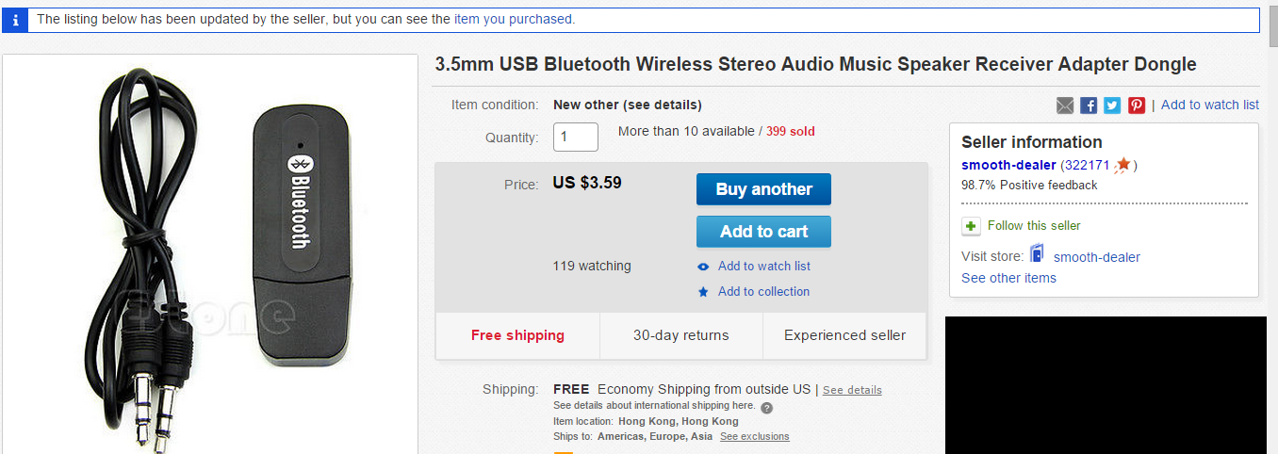

Installation is simple.

1. Plug the Bluetooth Receiver Adapter into a USB power source and power it up.
2. Plug the provided audio cable into the Auxiliary input to your Receiver (and Bluetooth Receiver).
3. Turn on your cell phone and go to Bluetooth Menu.
4. Select “Search for New Devices”
5. Connect to “YET-M1” or the name your Bluetooth Receiver Adapter uses.(This unit required no password, but common passwords are 0000 or 1234.
6. Select “Auxiliary Input” on your Stereo or Car Radio.
7. Play music or your favorite audio book on your cell phone.
8. Adjust the volume on your stereo to enjoy…..

Step 1 and 2

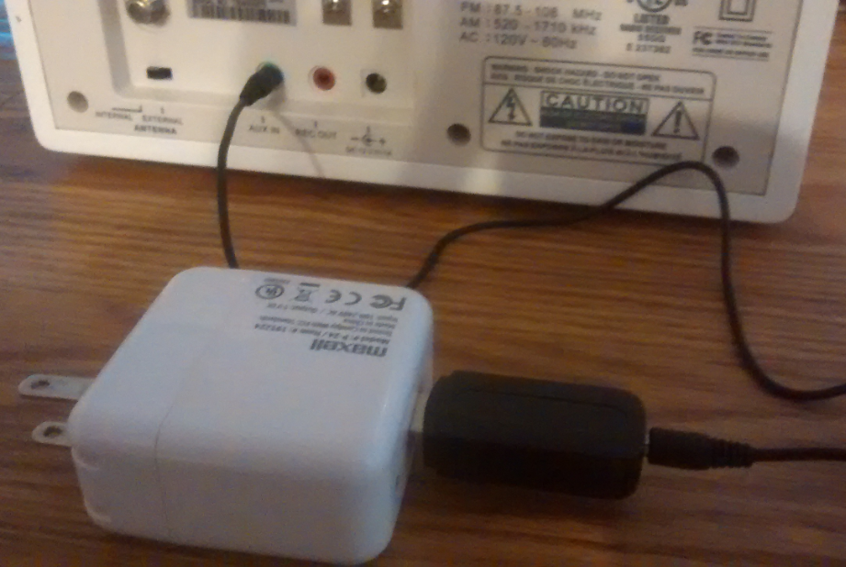

Step 3, 4, 5

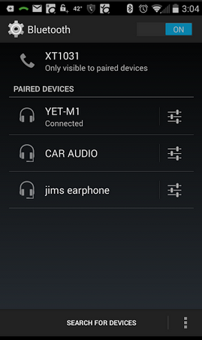

Step 6

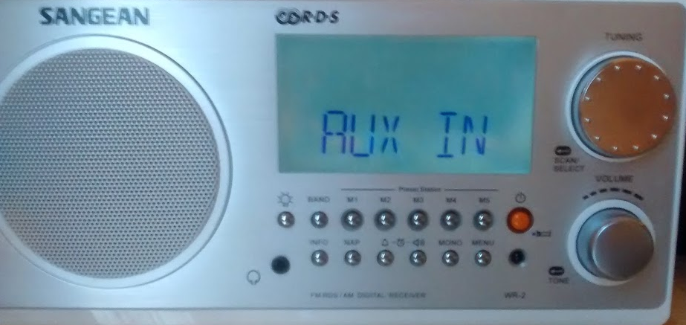

Steps 7, 8

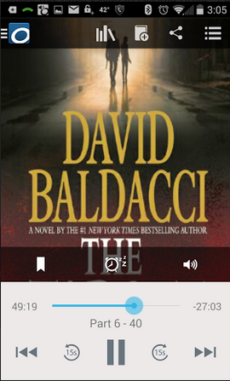

For the Car:

